

**Principles of Big Data**

**Project Report: Phase-3**

**Team Members**

**Megha Nagabhushan (16226858)**

**Khalid Almalki (16207381)**

**Akhila Katta (16232635)**

**Ahmed Albishri (16233350)**

**Supervision:**

**Dr. Anas Katib.**

**Introduction:**

Big data is an evolving term that describes any voluminous amount of structured, semi-structured and unstructured data that has the potential to be mined for information.  But it’s not the amount of data that’s important. Its what organizations do with the data that matters.

Big data is all about 3Vs: the extreme volume of data, the wide variety of types of data and the velocity at which the data must be must processed. Companies are trying to perform analytics on big data and get some valuable output which gives an edge over their competitors. Big data can generate significant financial value across sectors. We can achieve improved revenues at lower costs using Big data analytics. Accuracy in big data may lead to more confident decision making.

**Software’s used:**

Scala IDE

Hadoop

Eclipse IDE for Scala

IntelliJ

D3.js

Java script

HTML

CSS

Google Maps API

**Used Libraries :-**

* Twitter4J

**Development/testing machine’s specification:**

**Second Machine:  Windows Machine**

* 16GB RAM
* AMD FX(tm)-8350 Eight-Core Processor  4.00 GHz
* 64-bit Operating System, x64-based processor

**Second Machine:  MacBook pro**

 16GB Ram

 3.1 GHZ Intel Core - i7

 MacOS Sierra Operating System.

**Implementation:**

1.Collected tweets from Twitter Streaming API with filters as “Matthew hurricane”**.** This collected Json data is stored to a Json file.

2. The Json file was converted into Table/View in Scala.

3. Created web interface which gets data and visualizes the output in interesting charts using different charting js libraries.

4. Web interface has dropdown list of queries on selecting query, invokes html program which executes the query using spark library and returns Json data for visualization.

The queries were run on 3.87 GB of data collected by calling twitter API.

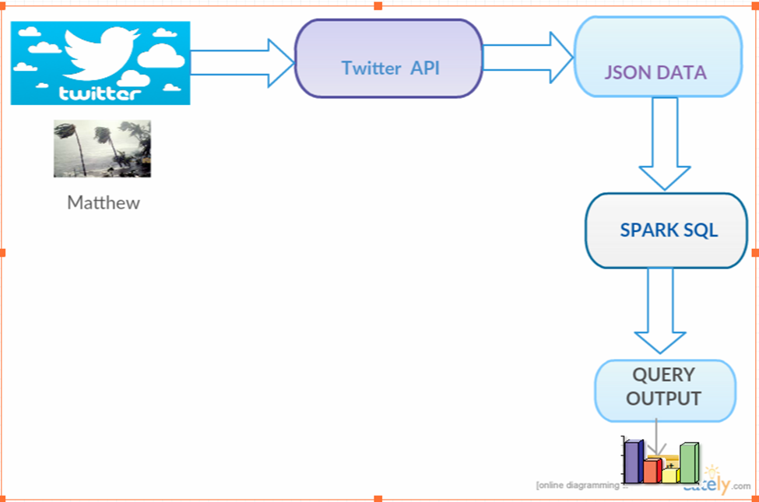

**Theme:**

**Matthew Hurricane:**

Hurricane Matthew was a very powerful, long-lived and deadly [tropical cyclone](https://en.wikipedia.org/wiki/Tropical_cyclone) which became the first [Category 5 Atlantic hurricane](https://en.wikipedia.org/wiki/List_of_Category_5_Atlantic_hurricanes) since [Hurricane Felix](https://en.wikipedia.org/wiki/Hurricane_Felix) in [2007](https://en.wikipedia.org/wiki/2007_Atlantic_hurricane_season). The thirteenth named storm, fifth hurricane and second [major hurricane](https://en.wikipedia.org/wiki/Major_hurricane) of the active [2016 Atlantic hurricane season](https://en.wikipedia.org/wiki/2016_Atlantic_hurricane_season), Matthew wrought widespread destruction and catastrophic loss of life during its journey across the Western Atlantic, including parts of [Haiti](https://en.wikipedia.org/wiki/Haiti), [Cuba](https://en.wikipedia.org/wiki/Cuba), [Dominican Republic](https://en.wikipedia.org/wiki/Dominican_Republic) and [Lucayan Archipelago](https://en.wikipedia.org/wiki/Lucayan_Archipelago), the [southeastern United States](https://en.wikipedia.org/wiki/Southeastern_United_States), and the [Canadian Maritimes](https://en.wikipedia.org/wiki/Canadian_Maritimes)

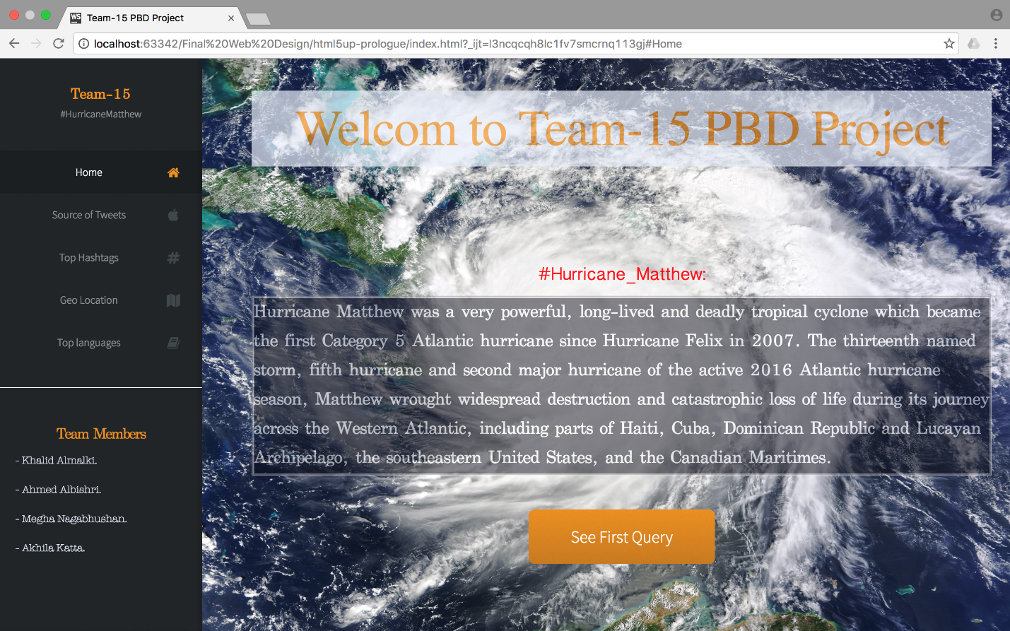

**Queries:**

**Query 1: Top Hashtags**

**val sql8 = spark.sql("SELECT LOWER(hashtags.text) As Hashtags, COUNT(*) AS total_count FROM tb1 LATERAL VIEW EXPLODE(entities.hashtags) t1 AS hashtags GROUP BY LOWER(hashtags.text) ORDER BY total_count DESC LIMIT 20")**

**sql8.show()**

The above query displays the most popular hash tags through suitable visualization.

And the runtime of the query is 40 seconds.

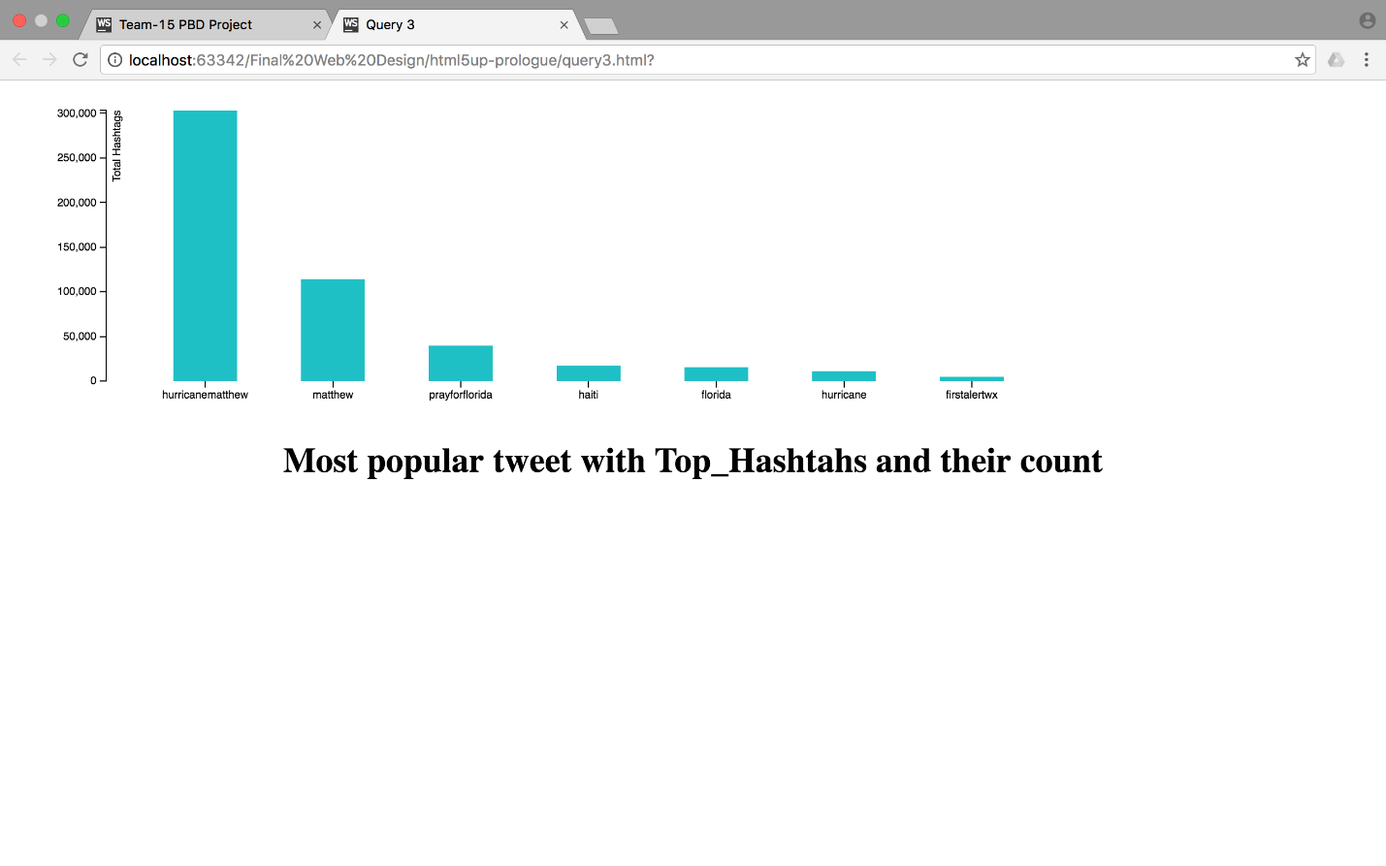

**Query 2: GEO Location(Extra credit query)**

val sql5 = spark.sql("SELECT user.name,user.screen_name,user.id,geo.coordinates[0] As latt,geo.coordinates[1] As long from tb5 where geo is not null")

    sql5.show()

      sql5.coalesce(1)

       .write.format("com.databricks.spark.csv")

       .option("header", "true")

       .save("D:/spark-test/testHash/GeoTest/Geo9.csv")

Dynamically executes query using Google Maps API upon the user’s click and displays user information by linking it to the user twitter account in a map visualization.

The run time of the query is 61 seconds.

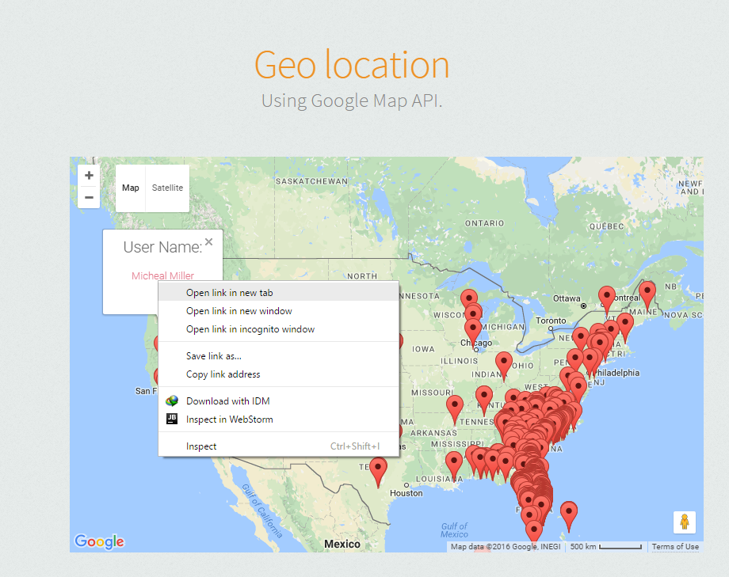

**Query 3:Top Languages**

var sqlDF = spark.sql("SELECT text from tb1 where user.verified=true AND lang="es")

The above query displays all those tweets which were written in different languages and also validates the user.

The run time of the query is seconds

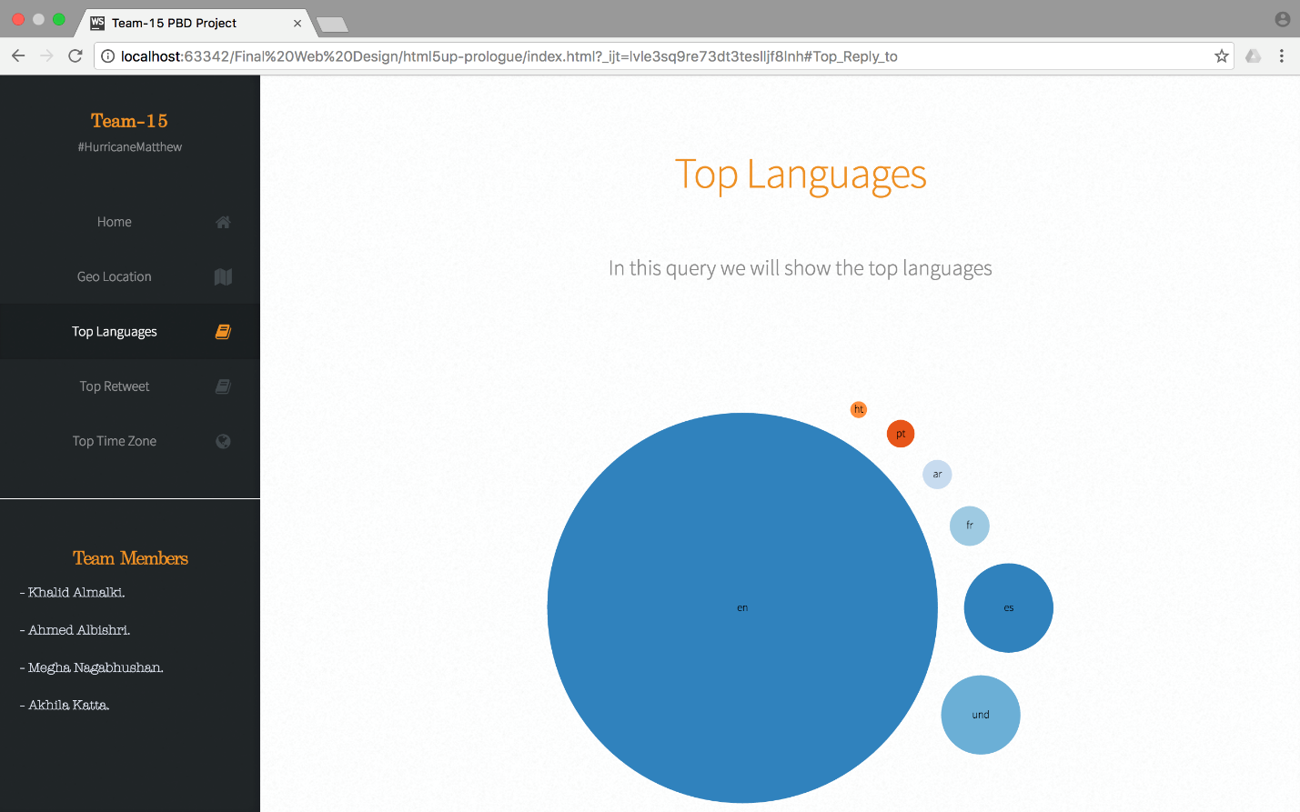

**Query 4: Top ReTweet**

val sql7 = spark.sql("SELECT retweeted_status.id, retweeted_status.text, COUNT(*) as total FROM tb1 WHERE retweeted_status.user is not null GROUP BY retweeted_status.id, retweeted_status.text ORDER BY total desc LIMIT 5")

The above Query retrieves the most common retweeted tweet and displays it.

The run time of the query is 44 seconds

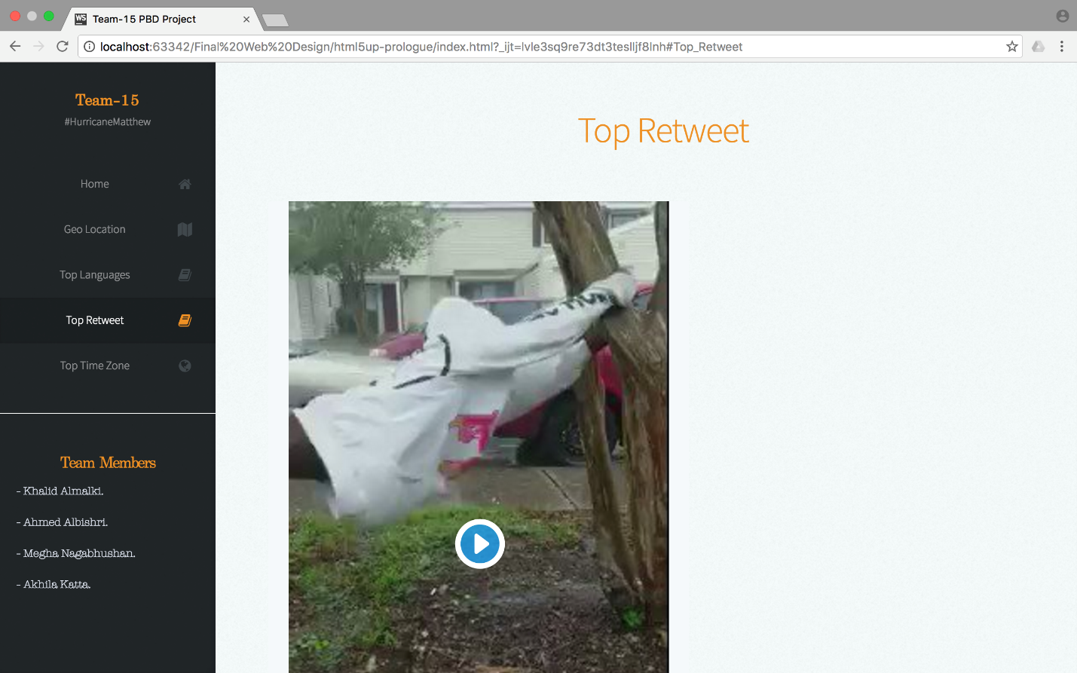

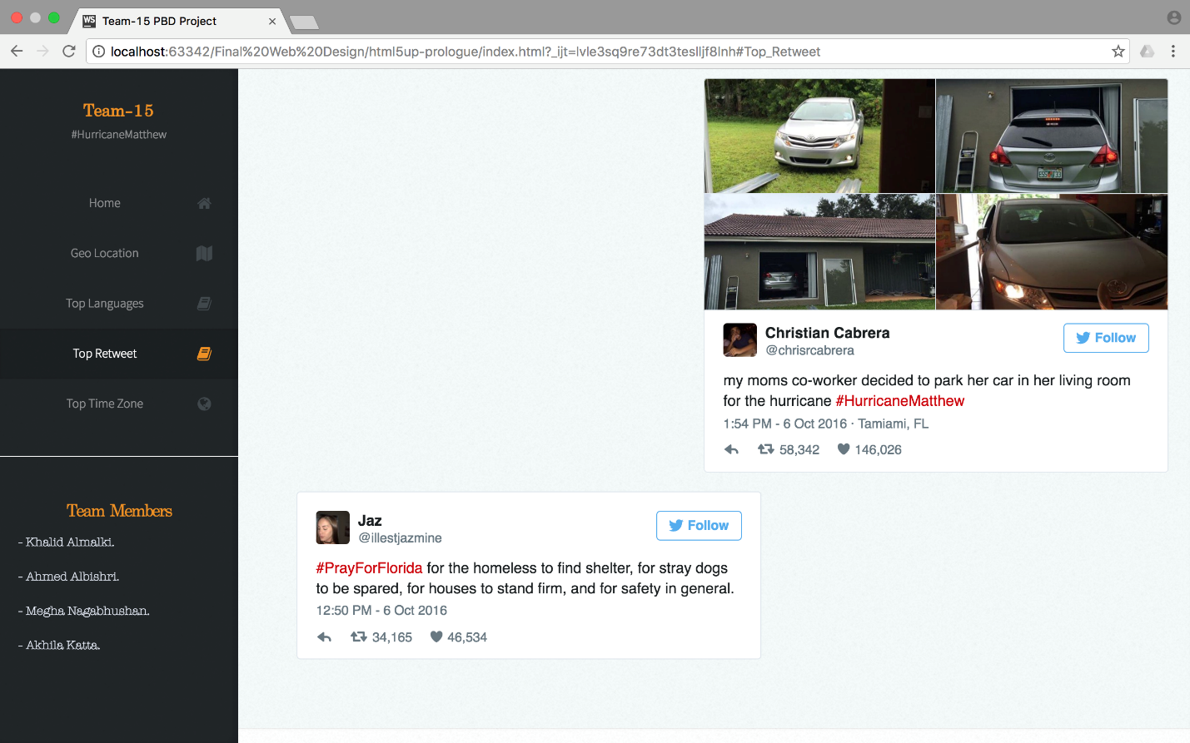

**Query 5: Top Timezone**

val sql5 = spark.sql("SELECT user.time_zone, COUNT(*) AS total_count FROM tb1 WHERE user.time_zone IS NOT NULL GROUP BY user.time_zone ORDER BY total_count DESC LIMIT 50")

The above Query displays the percentage of tweets from each time zone.

The run time of the query is 34 seconds.

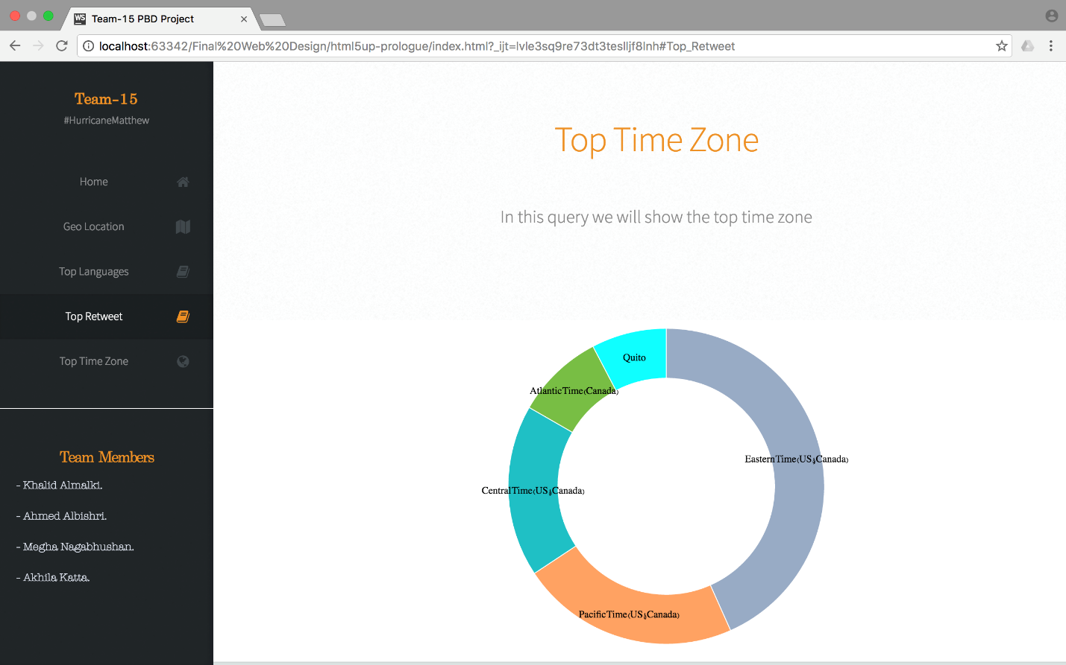

**Query 6: Source of Tweets(Extra Query)**

**val sql4 = spark.sql("SELECT sum(case when lower(source) like '%android%' then 1 else 0 end)android, sum(case when lower(source) like '%iphone%' then 1 else 0 end)iphone, sum(case when lower(source) like '%ipad%' then 1 else 0 end)ipad, sum(case when lower(source) like '%web%' then 1 else 0 end)web, sum(case when lower(source) like '%tweetdeck%' then 1 else 0 end)Tweetdeck, sum(case when lower(source) like '%tweetbot%' then 1 else 0 end)Tweetbot, sum(case when lower(source) like '%www.sprinklr.com%' then 1 else 0 end)Sprinklr, sum(case when lower(source) like '%www.socialnewsdesk.com%' then 1 else 0 end)SocialNewsDesk, sum(case when lower(source) like '%instagram.com%' then 1 else 0 end)Instagram, sum(case when lower(source) like '%facebook.com%' then 1 else 0 end)Facebook from tb1")**

**sql4.show()**

The above query calculates the number of users who sent tweets from Android Phones, Iphones, Ipod,  Web and also surveys the use of social networking by calculating number of users who sent tweets from Tweet deck, Tweet bot, Sprinklr, Social News Deck, Instagram, Facebook.

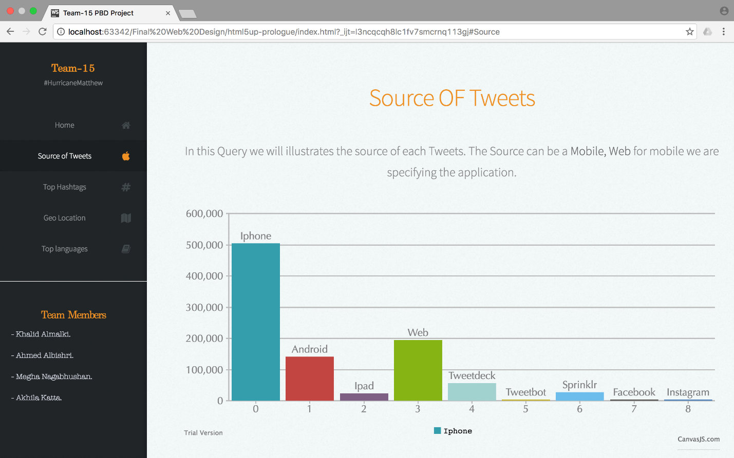

**Link to the source code and collected data:** https://drive.google.com/drive/folders/0Bx2PsZux5qFkU2dZRk5qTElXSnc?usp=sharing